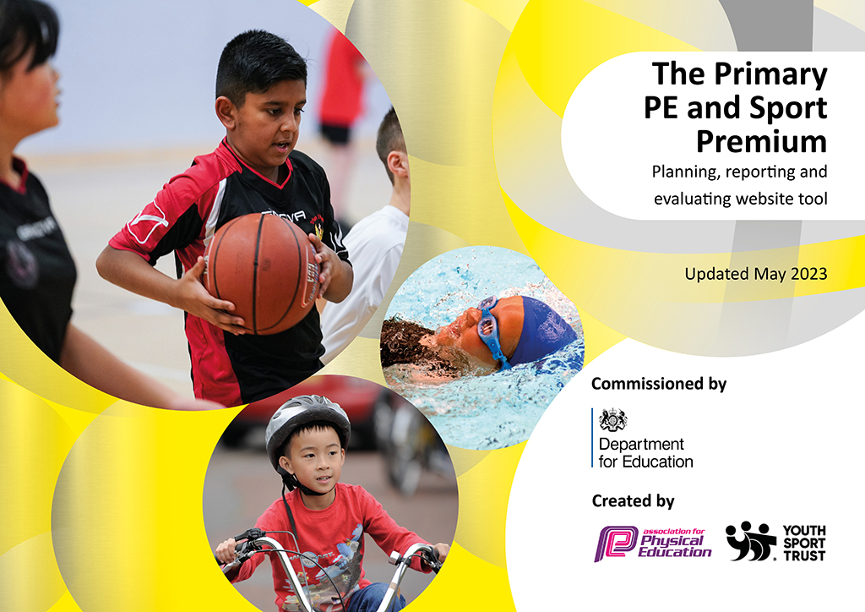
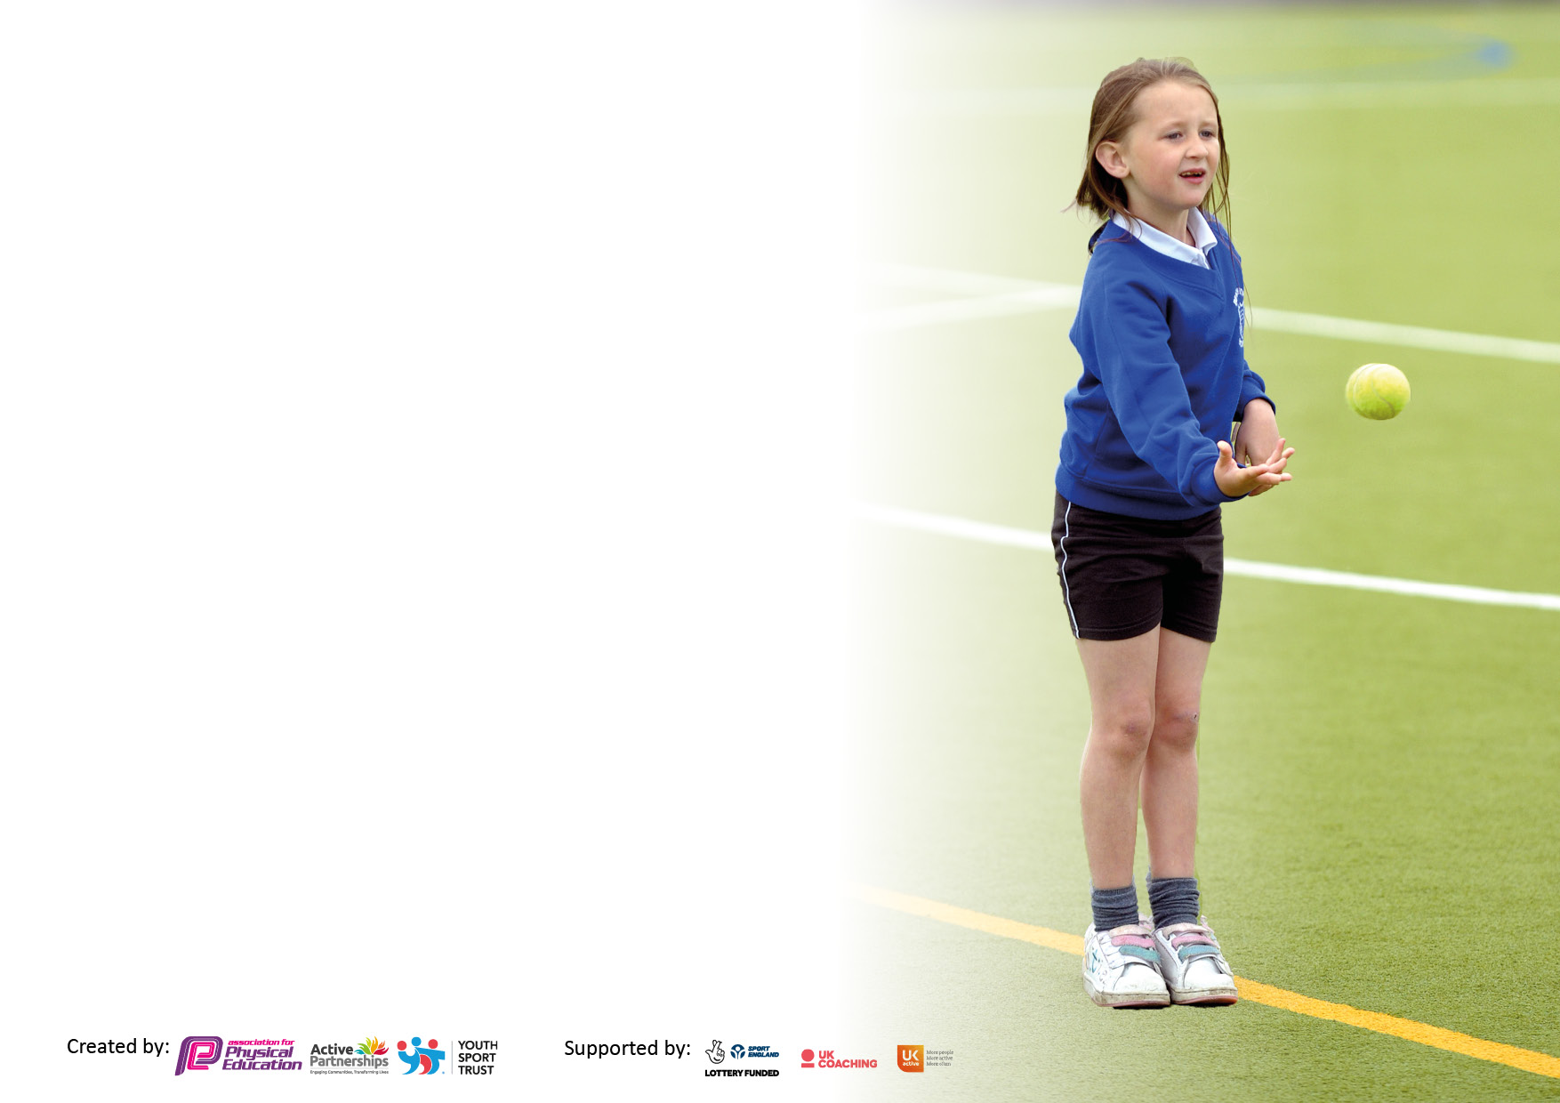

It is important that your grant is used effectively and based on school need. The Education Inspection Framework makes clear there will be a focus on ‘whether leaders and those responsible for governors all understand their respective roles and perform these in a way that enhances the effectiveness of the school’.

Under the Quality of Education Ofsted inspectors consider:
Intent - Curriculum design, coverage and appropriateness
Implementation - Curriculum delivery, Teaching (pedagogy) and Assessment
Impact - Attainment and progress

To assist schools with common transferable language this template has been developed to utilise the same three headings which should make your plans easily transferable between working documents.

Schools must use the funding to make additional and sustainable improvements to the quality of Physical Education, School Sport and Physical Activity (PESSPA) they offer. This means that you should use the Primary PE and sport premium to:

- Develop or add to the PESSPA activities that your school already offer
- Build capacity and capability within the school to ensure that improvements made now will benefit pupils joining the school in future years
- The Primary PE and sport premium should not be used to fund capital spend projects; the school’s budget should fund these.

Pleasevisitgov.ukfortherevisedDfEguidanceincludingthe5keyindicatorsacrosswhichschoolsshoulddemonstrate animprovement.Thisdocumentwillhelpyoutoreviewyourprovisionandtoreportyourspend.DfEencouragesschools to use this template as an effective way of meeting the reporting requirements of the Primary PE and Sport Premium.

We recommend you start by reflecting on the impact of current provision and reviewing the previous spend.

Schools are required to publish details of how they spend this funding, including any under-spend from 2021/2022, as well as on the impact it has on pupils’ PE and sport participation and attainment. All funding must be spent by 31st July 2023.

We recommend regularly updating the table and publishing it on your website throughout the year. This evidences your ongoing self-evaluation of how you are using the funding to secure maximum, sustainable impact. Final copy must be posted on your website by the end of the academic year and no later than the 31st July 2023. To see an example of how to complete the table please click HERE.

Details with regard to funding
Please complete the table below.

Total amount carried over from 2021/22 | £0
Total amount allocated for 2021/22 | £19,960
How much (if any) do you intend to carry over from this total fund into 2022/23? | £ Please complete for your school across both years – remember no carry forward beyond July 2023
Total amount allocated for 2022/23 | £19,970
Total amount of funding for 2023. To be spent and reported on by 31st July 2023. | £ 19,970
Swimming Data
Please report on your Swimming Data below.

Meeting national curriculum requirements for swimming and water safety.  N.B. Complete this section to your best ability. For example you might have practised safe self-rescue techniques on dry land which you can then transfer to the pool when school swimming restarts.  Due to exceptional circumstances priority should be given to ensuring that pupils can perform safe self rescue even if they do not fully meet the first two requirements of the NC programme of study | Complete to the best of your ability – list here how you have gathered the information ( survey , lessons , parents etc)  Lessons
What percentage of your current Year 6 cohort swim competently, confidently and proficiently over a distance of at least 25 metres?  N.B. Even though your pupils may swim in another year please report on their attainment on leaving primary school at the end of the summer term 2022.  Please see note above | 85%
What percentage of your current Year 6 cohort use a range of strokes effectively [for example, front crawl, backstroke and breaststroke]?  Please see note above | 85%
What percentage of your current Year 6 cohort perform safe self-rescue in different water-based situations? | 94%
Schools can choose to use the Primary PE and sport premium to provide additional provision for swimming but this must be for activity over and above the national curriculum requirements. Have you used it in this way? | Yes – As part of Castle Point and Rochford SSP we collectively contribute to a targeted Top Up Swimming holiday programme to support students to reach 25m. This is coordinated centrally by the SSP team.

Action Plan and Budget Tracking
Capture your intended annual spend against the 5 key indicators. Clarify the success criteria and evidence of impact that you intend to measure to evaluate for pupils today and for the future.

Academic Year: 2022/23 | Total fund allocated: £19960 | Date Updated: 20/7/2023
Key indicator 1: The engagement of all pupils in regular physical activity – Chief Medical Officers guidelines recommend that primary school pupils undertake at least 30 minutes of physical activity a day in school |  |  |  | Percentage of total allocation:
 |  |  |  | 39%
Intent | Implementation |  | Impact
Your school focus should be clear what you want the pupils to know and be able to do and about  what they need to learn and to  consolidate through practice: | Make sure your actions to achieve are linked to your intentions: | Funding allocated: | Evidence of impact: what do pupils now know and what can they now do? What has changed?: | Sustainability and suggested next steps:
SSP ‘BASIC MEMBERSHIP MODEL – Physical And Health and Wellbeing strands ( see attached)  To impact on all students in Key Stage 1 and 2.  Please note some aspects are deliberately targeted at least active children.  To build regular physical activity into the school day for all students.  To provide a breadth of opportunities for pupils to be active daily including break , lunch and cross curricular activities.  To work with the wider school community and workforce through targeted CPD to ensure staff are competent and confident in implementing daily activity strategies.  To work with the SSP through events and festivals to inspire regular activity and provide a daily mile/activity strategy.  To utilise the Active School Planner tool to identify areas to improve the offer across the day for students to be active. | 1. Select a group of children to attend 3 x Active Kids festivals to engage the least active students in the school in personal challenges and to develop a love of being active.( 3 x Multi skills virtual festival resources were created and made available to all schools, these included video instructions to allow children to complete the festival at home or in school)  2. Attendance of SSP Annual Conference May 2023 and training from Teach Active on approaches to make the school day more active.  3. ‘Active Breaks’ and challenges used to motivate children to participate in high quality physical activity.  4. High quality PE and lunchtime equipment purchased to motivate all children to be physically active. | Points 1-3 are all funded through SSP Basic membership.  Annual cost is divided equally across all 5 Key Objectives (£390)  Point 3 - £3,600  Point 4 - £3602.50 shared between Indicator 1 and 4. | 1. Pupils selected based on least active and least engaged. Children spoke positively of the events and were excited to be participating in more events.  2. New strategies to make more of the school day active through approach to literacy and numeracy  3. Pupils participate in active breaks regularly and enjoy trying to meet challenges set for their class. This has been most successful with the younger children developing fundamental movements and motivating physical activity.  4. Children engaged in a range of sport and have access to high quality equipment at all times during the day promoting physical activity during lunch and playtimes. | 1. Use the Personal Challenges to chart activity between festivals. Children feedback ideas to whole school through school council.  2. Information disseminated through all phases of school.  3. Staff in school to use these methods without support from outside leader.  4. Equipment developed to and utilized in active clubs targeted to specific pupils during lunch and playtimes.
Key indicator 2: The profile of PESSPA being raised across the school as a tool for whole school improvement |  |  |  | Percentage of total allocation:
 |  |  |  | 2%
Intent | Implementation |  | Impact
Your school focus should be clear what you want the pupils to know and be able to do and about  what they need to learn and to  consolidate through practice: | Make sure your actions to achieve are linked to your intentions: | Funding allocated: | Evidence of impact: what do pupils now know and what can they now do? What has changed?: | Sustainability and suggested next steps:
SSP ‘BASIC MEMBERSHIP MODEL – all strands contribute to this area ( see attached)  To impact on all students and staff in Key Stage 1 and 2.  To work with targeted pupils on whole school priorities using PE and School Sport as the vehicle to raise standards.  To ensure training takes place to enable the school to facilitate active and productive break and lunch times.  To ensure all staff access PE specific CPD across the academic year to raise the profile and importance of the subject.  To provide development support for staff to raise the quality of PE and School Sport on offer which , in turn, will raise the profile of the subject. | 1. Attendance at PE Lead meetings and share outcomes across whole school.( meetings for PE Leads)  2. Engagement of more staff in preparation of festivals and attendance to cross curricular CPD to ensure PE, SS and PA are impacting across all elements of school life  3. Distribution of termly SSP newsletter to raise awareness and raise profile across the school community. | Points 1-3 are all funded through SSP Basic membership.  Annual cost is divided equally across all 5 Key Objectives (£390) | 1. Registers and staff attendance.  2. An annual plan of involvement in festivals, e.g. LSA to lead preparation of Dance Festival. Aim to engage and raise profile across all staff. | 1. Regular PE feedback slot at staff meetings to share knowledge.  2. Develop an ethos of shared responsibility across PE, SS and Physical Activity.

Key indicator 3: Increased confidence, knowledge and skills of all staff in teaching PE and sport |  |  |  | Percentage of total allocation:
 |  |  |  | 16%
Intent | Implementation |  | Impact
Your school focus should be clear | Make sure your actions to | Funding | Evidence of impact: what do | Sustainability and suggested
what you want the pupils to know | achieve are linked to your | allocated: | pupils now know and what | next steps:
and be able to do and about | intentions: |  | can they now do? What has
what they need to learn and to |  |  | changed?:
consolidate through practice:
SSP ‘BASIC MEMBERSHIP MODEL – all strands contribute to this area (see attached) High Quality PE is most prominent.  To impact on all students and staff in Key Stage 1 and 2.  To ensure that all staff are trained in a range of topics to deliver high quality PE sessions.  To ensure students are able to actively participate in and contribute to high quality PE lessons.  To ensure that students have a broad and detailed knowledge of a wide range of sporting activities by the end of KS 2.  To ensure all students have a firm understanding of the importance of PE /SS and PA relevant to their age and stage.  To ensure students can select and make choices to participate in a wide range of their chosen extra-curricular activities , delivered by highly motivated and competent staff.  To utilise external expertise to ensure students benefit from detailed subject specific knowledge.  Students are exposed to and comfortable with participating in school sport opportunities with other schools. | 1. Attendance at SSP PE Lead meetings to gain knowledge to share (Delivered remotely)  2. Gathering and use of SSP PE resources to support staff in school with the delivery of lessons.  3. Wider use of SSP infrastructure to network and share ideas.  4. Team teaching of dance through subject expert leading sessions. | Points 1-6 are all funded through SSP Basic membership. Annual cost is divided equally across all 5 Key Objectives (£390)  Point 4. £2830 | 1. Records of meetings, notes and handouts.  2. Making use of the SSP resource bank to support schemes of work and lesson planning.  3. Attend and utilize SSP networking opportunities and sharing of ideas between schools.  4. Pupils have increased confidence when performing in front of peers. Fundamental movement skills developed and children gain creativity to adapt their movements to different styles of music. | 1. PE Lead has the opportunity to share within whole staff meetings.  2. Central whole school base for resources accessible to all in school.  3. Allowing staff time to attend events and then share findings.  4. Staff to lead more sessions to build confidence and skills in delivering high quality dance lessons.
Key indicator 4: Broader experience of a range of sports and activities offered to all pupils |  |  |  | Percentage of total allocation: 34%
Intent | Implementation |  | Impact
Your school focus should be clear | Make sure your actions to | Funding | Evidence of impact: what do | Sustainability and suggested
what you want the pupils to know | achieve are linked to your | allocated: | pupils now know and what | next steps:
and be able to do and about | intentions: |  | can they now do? What has
what they need to learn and to |  |  | changed?:
consolidate through practice:
SSP ‘BASIC MEMBERSHIP MODEL – all strands contribute to this area (see attached) School Sport is most prominent.  To impact on all students and staff in Key Stage 1 and 2  To ensure every child has the opportunity to represent the school in an external inter school competition , league or festival and be able to articulate how this made them feel.  To develop the ‘peer’ workforce to build the skills of young leaders to be able to motivate and inspire other young people in school to be active.  Students to be equipped by the end of KS 1 to enjoy a range of skills and activities to fully engage in active play and games.  Students to be equipped by the end of KS 2 to enjoy a wide range of sports and have the skills and competencies to both participate and compete.  To support each individual child to find ‘their’ chosen sport or activity.  To utilise SSP expertise to deliver a wide range of clubs and coaching opportunities to our students.  Our students will be able to clearly articulate which sports and activities they enjoy and why.  Our students will be able to use correct sporting terminology across a broad range of sports | 1. Access to broad range of Festivals, competitions and leagues. Preparing children.  2. Entering groups of children in events aimed at less active students e.g. Multi Skills Festival, Key Stage 1 Winter Games.  3. Engaging different students in performance based opportunities such as the Dance Festival, Cheerleading Competition and Skipping Festival. Ensuring children in school can access non-traditional sporting opportunities.(Adapted delivery – SSP Step Up and Dance Challenge (Spring), SSP Virtual Dance Festival ( Summer)  4. Engage with Active Kids Festivals (Adapted delivery – through virtual festivals , videos and resources)  5. Use of SSP Community club scheme to offer a wider range of extra curricular clubs.  6. Clubs organised across a wide range of activity types. These are before school, after school and during the school day to ensure maximum participation.  7. Equipment purchased to ensure a range of high quality sessions are available across a wide range of sports. | Points 1-5 are all funded through SSP Basic membership. Annual cost is divided equally across all 5 Key Objectives (£390)  6. £2,730  7. £3602.50 | 1. All events monitored and children selected appropriately.  2. Records of events and students selected – track pre and post levels of activity  3. Entry details in these events. Children are rotated and selected to broaden participation.  4. As above  5. Completion of community club request sheet. Requests based on consulting students, records of need. Allocation and timetable of breakfast, lunchtime and after school clubs maintained and monitored.  6. Children and parents consulted to ensure clubs meet the needs of the pupils and all children can be actively engaged.  7. High quality equipment used to ensure all clubs are engaging and interesting to the pupils. | 1. A plan to ensure all students have termly opportunities to prepare, attend and represent school.  2. Tracking of students attendance and engagement in broader extra- curricular sport post event.  3. A school plan to allocate different opportunities to different year groups and target groups of children.  4. Tracking of engagement in broader clubs and extra-curricular opportunities  .  5. Mapping club programme to a wider range of festivals and competitions and festivals to track. Allowing our own school staff to support experts in a range of clubs.  6. Club records maintained and clubs rotated to target specific and least active children  7. rolling progression of different equipment to be purchased to maintain and build on sport activities which are available.

Key indicator 5: Increased participation in competitive sport |  |  |  | Percentage of total allocation:
 |  |  |  | 9%
Intent | Implementation |  | Impact
Your school focus should be clear | Make sure your actions to | Funding | Evidence of impact: what do | Sustainability and suggested
what you want the pupils to know | achieve are linked to your | allocated: | pupils now know and what | next steps:
and be able to do and about | intentions: |  | can they now do? What has
what they need to learn and to |  |  | changed?:
consolidate through practice:
SSP ‘BASIC MEMBERSHIP MODEL – all strands contribute to this area (see attached) School Sport is most prominent.  To impact on all students and staff in Key Stage 1 and 2.  To identify a wide range of sporting festivals and sports for our school and students to participate in.  To ensure every child enjoys the experience of representing the school in a festival, league or competition ( appropriate to their needs) and is able to articulate the learning taken from the experience.  To utilise whole school intra competition to raise standards across all subjects with PE and SS as the initial driver.  Students to understand and be able to deal with emotionally , both winning and losing in sport. | 1. Involvement of a wide range of students in a broad offer of competitions (Adapted delivery – engagement in the virtual offer of competitions, festivals and challenges)  2. Participation in SSP Football and Netball leagues to increase regular competitive opportunities.  3. Entry into Dance Festival  4. Development of intra (in school) competitive opportunities.  5. Travel to sports events both at local, county and regional level paid for to remove barriers. | Points 1-4 are all funded through SSP Basic membership  Annual cost is divided equally across all 5 Key Objectives (£390  5. £1505 | 1. List of competitions entered and records of students attending. Competitive calendar linked to SSP website.  2. Records of fixtures, training and participants.  3. List of students and programme from the event.  4. Annual plan of intra competition to act as trials for inter competition.  5. Sports events with mass participation have travel organised to increase competitive participation. | 1. Annual calendar discussed and produced in consultation with staff and students. Whole school plan to grow offer on a termly basis.  2. Engagement of a wide range of teaching and support staff in fixtures, transport and training. Investment in kit.  3. In school performance to engage and inspire future students.  4. Build intra competition into whole school diary  5. Develop parental support to reduce cost of travel to some sport events.

Signed off by
Head Teacher:
Date:
Subject Leader: | Steve Jetten
Date: | 20/7/2023
Governor:
Date:

